P300 Speller

Brain Computer Interface Lab ECBM 4090

10/16/2024

Ian Huang, Lindsey Ma, Giuliana Cascarano

[Nima Mesgarani](mailto:nima@ee.columbia.edu)

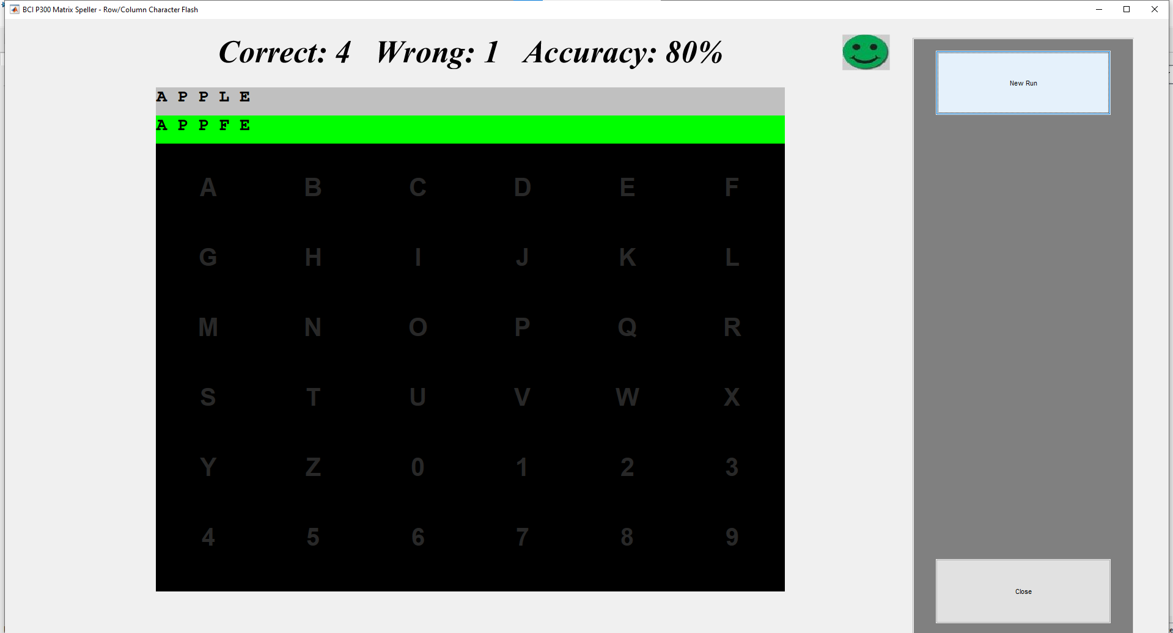

**We did not do the team name! We accidentally thought it meant to name that file our team name. We actually did it twice and got 93% accuracy when we spelled applebees.**